SEGi University
Faculty of Computing and Informatics
ASSIGNMENT REPORT
BIT1323
Integrated System Technology
Semester: January – April 2026
Submitted by
Full Name | Takrim Noor Hamim
Student ID | SUKD2501817
Module Code | BIT1323
Module Name | Integrated System Technology
Lecturer
Submission Date
Declaration
I hereby declare that this assignment is my own work and has not been submitted previously for any other course or assessment. All sources used have been properly acknowledged.
Signature: Takrim

Table of Contents

1. Requirement Analysis (Task 1)
1.1 Input Requirements
1.2 Process Requirements
1.3 Output Requirements
2. Integration Design Diagram (Task 2)
3. Script Implementation (Task 3)
3.1 File Structure
3.2 inventory.json
3.3 inventory_module.py
3.4 sales_module.py
3.5 validator.py
3.6 main.py
3.7 Testing & Running the System
4. API Simulation & Security (Task 4)
4.1 Part A — API Simulation (json.dumps / json.loads)
4.2 Part B — Secure Coding & Input Validation
5. References

Task 1: Requirement Analysis
Category | Data / Field | Description | Source → Destination | Validation Rule
INPUT | Book ISBN  isbn | Unique identifier entered by the customer to specify which book they wish to purchase. | Customer → Sales Module | Must be a non-empty string. Must exist in the inventory database.
INPUT | Quantity  quantity | Number of book copies the customer wishes to purchase in a single transaction. | Customer → Sales Module | Must be a positive integer (> 0). Cannot exceed available stock.
INPUT | Customer Email  PII – Sensitive | Customer email for receipt identification. Classified as Personally Identifiable Information (PII). Masked before any transmission. | Customer → Sales Module | Must match valid email format (regex). Masked before json.dumps().
PROCESS | ISBN Validation  validate_isbn() | Checks whether the provided ISBN key exists in the inventory dictionary. Halts transaction immediately if not found. | Sales Module → validator.py | If ISBN not in inventory → return error, stop transaction.
PROCESS | Quantity Validation  validate_quantity() | Verifies the quantity is a whole number and greater than zero before any processing begins. | Sales Module → validator.py | If ≤ 0 or non-integer → return error string.
PROCESS | Stock Availability Check  validate_stock() | Compares the requested quantity against current stock in the inventory database to ensure the order can be fulfilled. | Sales Module → validator.py | If requested > available → "Error: Insufficient Stock" message.
PROCESS | Email Masking  _mask_email() | Masks the customer email (e.g. alice@mail.com → a***@mail.com) before data travels via JSON to prevent raw PII exposure. | Sales Module (security layer) | Applied after email validation, before json.dumps().
PROCESS | JSON Serialisation  json.dumps() | Sales Module converts the Python order dictionary into a JSON string to simulate an API request to the Inventory Module. | Sales Module → Inventory Module | Payload: isbn, quantity, masked customer_email.
PROCESS | JSON Deserialisation  json.loads() | Inventory Module parses the received JSON string back into a Python dictionary to extract and process the order details. | Inventory Module (receive_order) | Standard JSON parsing; handles malformed input gracefully.
PROCESS | Stock Deduction  receive_order() | Subtracts the sold quantity from the book's stock count in the inventory database, then saves the updated value back to inventory.json. | Inventory Module → inventory.json | new_stock = current_stock − quantity_sold.
PROCESS | Low Stock Alert Check  threshold ≤ 5 | After stock deduction, checks whether remaining stock has fallen to 5 or below. If so, a reorder warning is printed to the terminal. | Inventory Module → Terminal | Triggers when remaining_stock ≤ 5.
PROCESS | Total Price Calculation  price × quantity | Calculates total transaction cost by multiplying the unit price (from inventory database) with the quantity ordered. | Sales Module | unit_price × quantity = total_price (RM).
OUTPUT | Purchase Receipt  Terminal display | Formatted receipt shown to the customer: book title, ISBN, quantity, unit price, total price, masked email, and remaining stock after sale. | Sales Module → Terminal | Only generated on a fully successful transaction.
OUTPUT | Inventory Update  inventory.json | The updated stock value is written back to the JSON database file, persisting changes across all future program sessions. | Inventory Module → database/inventory.json | File overwritten with updated stock values after every sale.
OUTPUT | Low Stock Warning  ⚠ Alert | Warning message printed to terminal indicating a book is critically low and must be reordered by bookstore staff. | Inventory Module → Terminal | Conditional: fires only when remaining_stock ≤ 5.
OUTPUT | Error Messages  Validation errors | Descriptive error strings returned at each failed validation step. No data is written to the database when an error occurs. | validator.py → Sales Module → Terminal | Transaction halted at first failed check.

Task 2: Integration Design Diagram
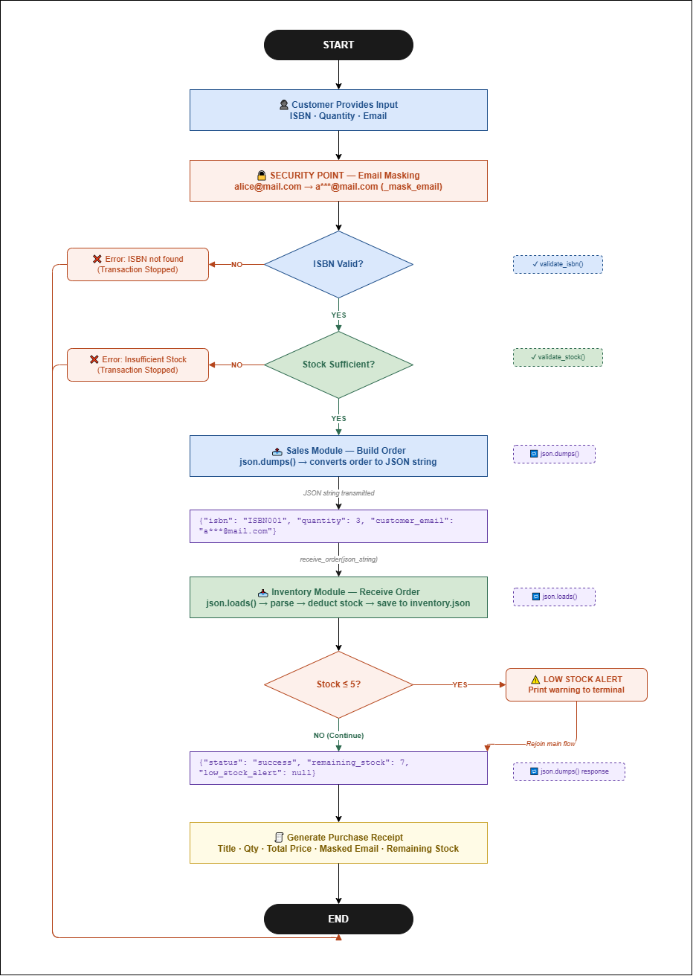
Draw.io File of the above Diagram:

Task 3: Script Implementation
I made the script’s file structure like this :
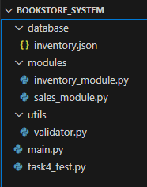
So, if you want to test all of my codes then you have to follow this file structure and file naming system.

If you prefer, you may download the complete project using the provided archive file instead of copying the code manually:

Below are all of the codes:
inventory.json file:
{
"ISBN001": {
"title": "The Hobbit",
"author": "J.R.R. Tolkien",
"price": 45.0,
"stock": 44
},
"ISBN002": {
"title": "Harry Potter",
"author": "J.K. Rowling",
"price": 55.0,
"stock": 33
},
"ISBN003": {
"title": "Clean Code",
"author": "Robert C. Martin",
"price": 80.0,
"stock": 12
},
"ISBN004": {
"title": "Python Crash Course",
"author": "Eric Matthes",
"price": 65.0,
"stock": 15
},
"ISBN005": {
"title": "Java Course",
"author": "Takrim Noor Hamim",
"price": 65.0,
"stock": 9
}
}

inventory_module.py file:
import json
import os

LOW_STOCK_THRESHOLD = 5
DB_PATH = os.path.join(os.path.dirname(__file__), '..', 'database', 'inventory.json')

def load_inventory():
"""Load the inventory dictionary from the JSON database file."""
with open(DB_PATH, 'r') as f:
return json.load(f)

def save_inventory(inventory):
"""Save the updated inventory dictionary back to the JSON database file."""
with open(DB_PATH, 'w') as f:
json.dump(inventory, f, indent=4)

def receive_order(json_string):
"""
Inventory Function:
- Receives a JSON string from the Sales module.
- Parses it back into a Python object using json.loads().
- Subtracts the sold quantity from the database.
- Triggers a Low Stock Alert if stock falls to 5 or below.
- Returns a JSON string result back to the caller.
"""
# ── Step 1: JSON string → Python dict (API simulation: json.loads)
order = json.loads(json_string)
isbn = order["isbn"]
quantity = order["quantity"]

# ── Step 2: Load current inventory from database
inventory = load_inventory()

# ── Step 3: Subtract quantity
inventory[isbn]["stock"] -= quantity
book_title = inventory[isbn]["title"]
remaining = inventory[isbn]["stock"]

# ── Step 4: Save updated inventory
save_inventory(inventory)

# ── Step 5: Low stock alert
alert = None
if remaining <= LOW_STOCK_THRESHOLD:
alert = (
f"⚠️ LOW STOCK ALERT: '{book_title}' has only {remaining} copies left! "
f"Please reorder soon."
)
print(alert)

# ── Step 6: Build result and return as JSON string
result = {
"status": "success",
"isbn": isbn,
"title": book_title,
"quantity_sold": quantity,
"remaining_stock": remaining,
"low_stock_alert": alert
}
return json.dumps(result, indent=2) # json.dumps() → Python dict to JSON string

def show_inventory():
"""Print current inventory status in a readable format."""
inventory = load_inventory()
print("\n" + "=" * 68)
print(f"{'📚 CURRENT INVENTORY STATUS':^68}")
print("=" * 68)
print(f"{'ISBN':<10} {'Title':<25} {'Unit Price (RM)':>16} {'Stock':>8}")
print("-" * 68)
for isbn, details in inventory.items():
stock_display = f"{details['stock']}"
if details["stock"] <= LOW_STOCK_THRESHOLD:
stock_display += " ⚠️"
print(f"{isbn:<10} {details['title']:<25} {details['price']:>14.2f} {stock_display:>8}")
print("=" * 68 + "\n")

sales_module.py file:
import json
from utils.validator import validate_isbn, validate_quantity, validate_stock, validate_email
from modules.inventory_module import load_inventory, receive_order

def process_order(isbn, quantity, customer_email):
"""
Sales Function:
- Validates all inputs (ISBN, quantity, stock availability, email).
- Masks the customer email for security before any logging/display.
- Builds an order object and serialises it to a JSON string using json.dumps().
- Sends that JSON string to the Inventory module's receive_order().
- Parses the response JSON string back using json.loads().
- Returns a formatted receipt string.
"""
# ── Step 1: Load inventory for validation
inventory = load_inventory()

# ── Step 2: Validate ISBN
ok, msg = validate_isbn(isbn, inventory)
if not ok:
return msg

# ── Step 3: Validate quantity (type check)
ok, msg = validate_quantity(quantity)
if not ok:
return msg

# ── Step 4: Validate stock availability
ok, msg = validate_stock(isbn, quantity, inventory)
if not ok:
return msg

# ── Step 5: Validate email (Security Point – protect PII)
ok, msg = validate_email(customer_email)
if not ok:
return msg

# ── Step 6: Mask email for any display/logging (e.g. alice@mail.com → a***@mail.com)
masked_email = _mask_email(customer_email)

# ── Step 7: Build order payload and convert to JSON string (json.dumps)
book = inventory[isbn]
order = {
"isbn": isbn,
"quantity": quantity,
"customer_email": masked_email # never store raw email in transit
}
order_json_string = json.dumps(order) # Python dict → JSON string

print(f"\n📤 Sales Module sending order to Inventory Module...")
print(f" JSON Payload: {order_json_string}")

# ── Step 8: Send JSON string to Inventory module (module-to-module communication)
response_json_string = receive_order(order_json_string)

# ── Step 9: Parse response (json.loads)
response = json.loads(response_json_string)

# ── Step 10: Generate and return receipt
total_price = book["price"] * quantity
receipt = _generate_receipt(isbn, book, quantity, total_price, masked_email, response)
return receipt

def _mask_email(email):
"""Security helper: mask email so raw PII is never exposed in logs."""
local, domain = email.split("@")
return local[0] + "***@" + domain

def _generate_receipt(isbn, book, quantity, total_price, masked_email, inv_response):
"""Build a readable receipt string."""
lines = [
"\n" + "=" * 50,
f"{'🧾 PURCHASE RECEIPT':^50}",
"=" * 50,
f" Book Title : {book['title']}",
f" Author : {book['author']}",
f" ISBN : {isbn}",
f" Quantity : {quantity}",
f" Unit Price : RM {book['price']:.2f}",
f" Total Price : RM {total_price:.2f}",
f" Customer : {masked_email}",
"-" * 50,
f" Status : ✅ Order Successful",
f" Remaining : {inv_response['remaining_stock']} copies left in stock",
"=" * 50,
]
return "\n".join(lines)

validator.py file:
import re

def validate_isbn(isbn, inventory):
"""Check if the ISBN exists in the inventory database."""
if not isbn or not isinstance(isbn, str):
return False, "Error: ISBN must be a non-empty string."
if isbn not in inventory:
return False, f"Error: Book with ISBN '{isbn}' does not exist in inventory."
return True, "ISBN is valid."

def validate_quantity(quantity):
"""Check if the quantity is a positive integer."""
if not isinstance(quantity, int) or isinstance(quantity, bool):
return False, "Error: Quantity must be a whole number (integer)."
if quantity <= 0:
return False, "Error: Quantity must be greater than zero."
return True, "Quantity is valid."

def validate_stock(isbn, quantity, inventory):
"""Check if there is enough stock to fulfill the order."""
available = inventory[isbn]["stock"]
if quantity > available:
return False, (
f"Error: Insufficient Stock. "
f"Requested {quantity}, but only {available} available for '{inventory[isbn]['title']}'."
)
return True, "Stock is sufficient."

def validate_email(email):
"""Basic check that the email looks valid before storing/using it."""
pattern = r'^[\w\.-]+@[\w\.-]+\.\w{2,}$'
if not email or not re.match(pattern, email):
return False, "Error: Invalid email address format."
return True, "Email is valid."

main.py file:
import sys
import os

sys.path.insert(0, os.path.dirname(__file__))

from modules.inventory_module import show_inventory
from modules.sales_module import process_order

def main():
print("\n" + "=" * 50)
print(f"{'📚 BOOKSTORE INTEGRATED SYSTEM':^50}")
print("=" * 50)

while True:
print("\nOptions:")
print(" 1. Place an order")
print(" 2. View current inventory")
print(" 3. Exit")
choice = input("\nEnter choice (1/2/3): ").strip()

if choice == "1":
isbn = input("Enter ISBN : ").strip()
qty_str = input("Enter Quantity : ").strip()
email = input("Enter Email : ").strip()

try:
qty = int(qty_str)
except ValueError:
print("❌ Quantity must be a number.")
continue

result = process_order(isbn, qty, email)
print(result)

elif choice == "2":
show_inventory()

elif choice == "3":
print("\n👋 Goodbye!")
break

else:
print("❌ Invalid choice. Enter 1, 2, or 3.")

if __name__ == "__main__":
main()

Testing our code:
After writing codes then you can run by putting “python main.py” command in the terminal:

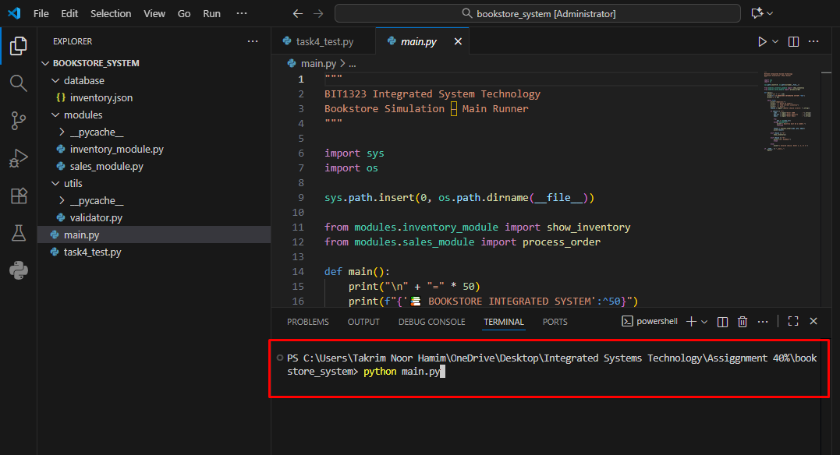

Then you can actually Place Order or View Inventory:

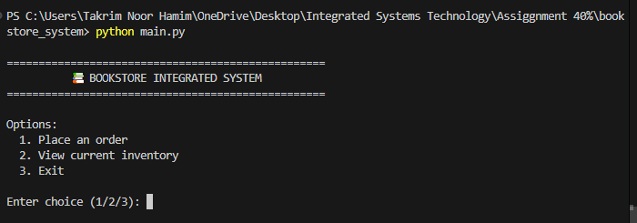

Let’s see the inventory first:

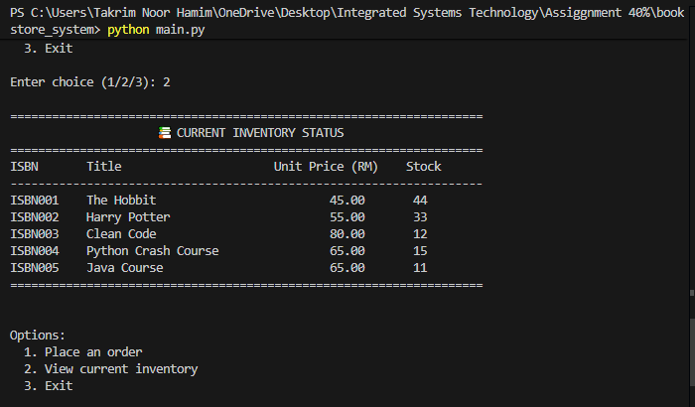

Let’s Place an order now, I ordered my book haha:

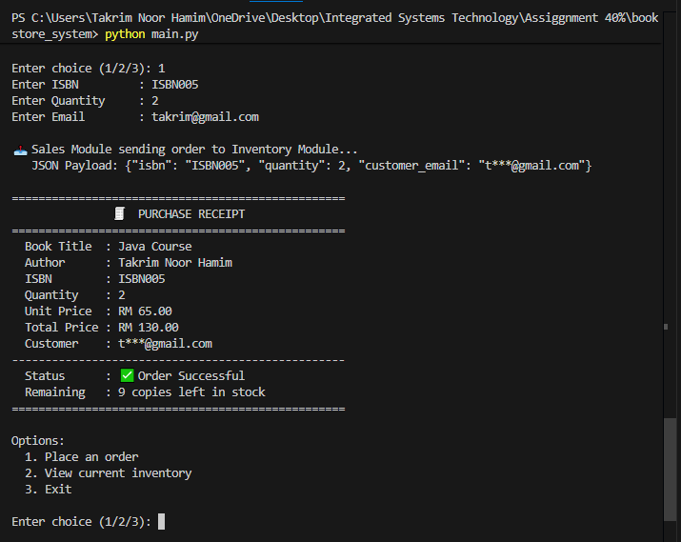

As you can see my inventory’s stock also changed from 11 to 9 after my order:

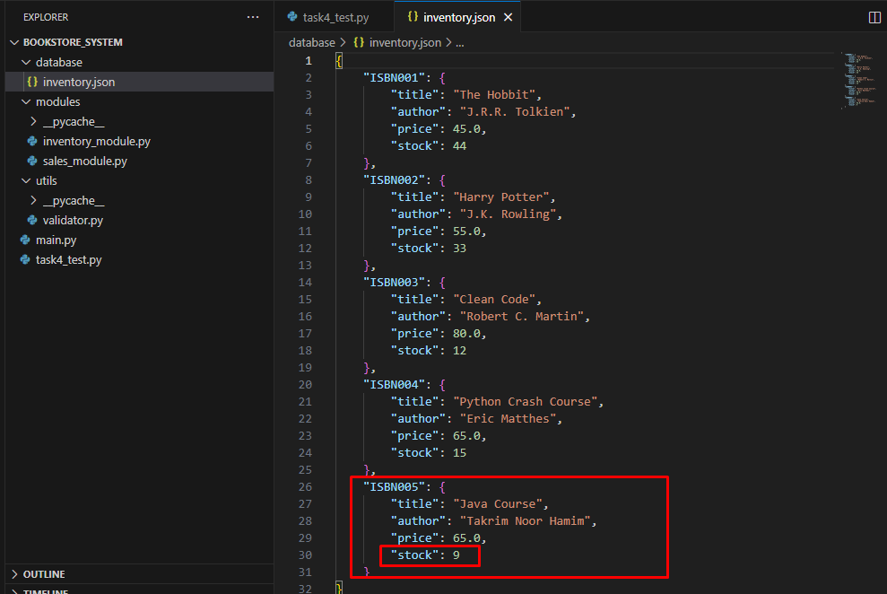
Let’s see what really shows when the books are low on stock:

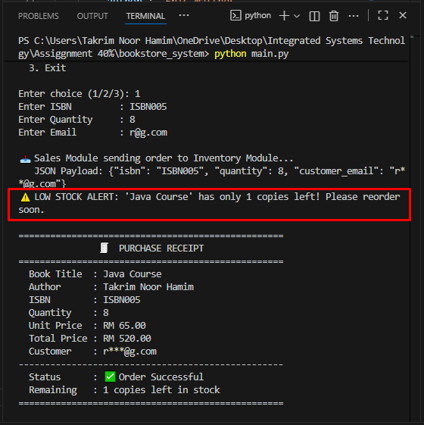

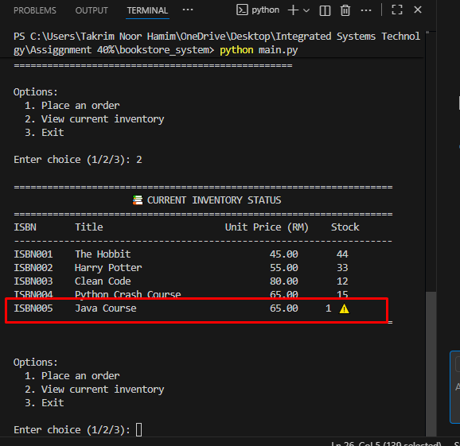

As you can see there’s a warning sign when a book is low in stock.

Task 4: API Simulation & Security
Now we have to add one more Script in the main folder that do the task 4’s part.

task4_test.py file:
"""
Task 4: API Simulation & Security — Demonstration Script
"""

import sys, os, json
sys.path.insert(0, os.path.dirname(__file__))

from modules.inventory_module import load_inventory
from utils.validator import validate_isbn, validate_quantity, validate_stock, validate_email

LINE = "=" * 65
DASH = "-" * 65

# ══════════════════════════════════════════════════════════════════
# PART A: API SIMULATION
# Goal: Prove that Sales Module and Inventory Module communicate
# using JSON — just like real APIs do over the internet.
# ══════════════════════════════════════════════════════════════════

print(f"\n{LINE}")
print(" TASK 4 — PART A: API SIMULATION")
print(f"{LINE}")
print("""
WHAT IS API SIMULATION?
In a real system, two software modules send data to each other
over the internet as JSON text (like WhatsApp messages).
Here we simulate that using:
→ json.dumps() : converts Python data → JSON string (SENDING)
→ json.loads() : converts JSON string → Python data (RECEIVING)
""")

print(DASH)
print("STEP 1 — Sales Module builds an order as a Python dictionary")
print(DASH)

order_dict = {
"isbn": "ISBN001",
"quantity": 3,
"customer_email": "a***@example.com" # already masked for security
}

print(f" order = {order_dict}")
print(f" Type : {type(order_dict)}")
print("""
WHY: Python dictionaries cannot be sent between modules directly.
We must convert it to a text format (JSON) first.
""")

print(DASH)
print("STEP 2 — json.dumps() converts the dict to a JSON string")
print(" This simulates SENDING the order to Inventory Module")
print(DASH)

json_string = json.dumps(order_dict)

print(f" json.dumps(order) → '{json_string}'")
print(f" Type : {type(json_string)}")
print("""
WHY: json.dumps() turns Python data into a plain string.
This string can now travel between modules (like an API request).
Notice: it looks similar but is now a STRING, not a dict.
""")

print(DASH)
print("STEP 3 — json.loads() converts the JSON string back to a dict")
print(" This simulates RECEIVING the order in Inventory Module")
print(DASH)

received = json.loads(json_string)

print(f" json.loads(json_string) → {received}")
print(f" Type : {type(received)}")
print("""
WHY: The Inventory Module receives the raw string.
json.loads() converts it back into a usable Python dictionary
so the module can read isbn, quantity, etc.
""")

print(DASH)
print("RESULT — Full round-trip confirmed:")
print(DASH)
print(f" ISBN : {received['isbn']}")
print(f" Quantity : {received['quantity']}")
print(f" Email : {received['customer_email']}")
print("""
CONCLUSION:
✅ json.dumps() successfully converted Python dict → JSON string
✅ JSON string successfully transmitted between modules
✅ json.loads() successfully converted JSON string → Python dict
✅ All data values intact after round-trip
→ This proves the two modules communicate via JSON (API Simulation)
""")

# ══════════════════════════════════════════════════════════════════
# PART B: SECURE CODING — INPUT VALIDATION
# Goal: Prove the system handles bad input safely without crashing
# or writing corrupt data (like negative stock) to the database.
# ══════════════════════════════════════════════════════════════════

print(f"\n{LINE}")
print(" TASK 4 — PART B: SECURE CODING & INPUT VALIDATION")
print(f"{LINE}")
print("""
WHAT IS SECURE CODING / INPUT VALIDATION?
When a user enters wrong data (e.g. buying 999 books when only 10
exist), the system must NOT crash or allow negative stock.
Instead, it must return a clear error message.

Our validator.py checks 4 things before any order is processed:
1. validate_isbn() → Does this book exist?
2. validate_quantity() → Is the quantity a valid positive number?
3. validate_stock() → Is there enough stock?
4. validate_email() → Is the email in correct format?

SECURITY BONUS:
_mask_email() hides the raw email (alice@x.com → a***@x.com)
before it travels in JSON, protecting customer PII data.
""")

inventory = load_inventory()

tests = [
{
"title" : "TEST 1 — VALID ORDER (everything correct)",
"explain": "All inputs are valid. The order should pass every check.",
"isbn" : "ISBN001", "qty": 3, "email": "alice@example.com",
"expect" : "Order proceeds successfully"
},
{
"title" : "TEST 2 — INVALID ISBN (book does not exist)",
"explain": "ISBN999 is not in our database. System must catch this\n"
" and stop immediately — no stock should be touched.",
"isbn" : "ISBN999", "qty": 1, "email": "bob@mail.com",
"expect" : "Error: ISBN not found"
},
{
"title" : "TEST 3 — INSUFFICIENT STOCK (requests more than available)",
"explain": "Customer wants 999 copies but stock is limited.\n"
" System must block this — stock must NEVER go negative.",
"isbn" : "ISBN001", "qty": 999, "email": "carol@mail.com",
"expect" : "Error: Insufficient Stock"
},
{
"title" : "TEST 4 — INVALID QUANTITY (negative number)",
"explain": "Quantity of -5 makes no sense. System must reject it.",
"isbn" : "ISBN002", "qty": -5, "email": "dave@mail.com",
"expect" : "Error: Quantity must be greater than zero"
},
{
"title" : "TEST 5 — INVALID QUANTITY (zero)",
"explain": "Buying 0 copies is meaningless. System must reject it.",
"isbn" : "ISBN002", "qty": 0, "email": "eve@mail.com",
"expect" : "Error: Quantity must be greater than zero"
},
{
"title" : "TEST 6 — INVALID EMAIL FORMAT",
"explain": "Email must be in valid format (e.g. name@domain.com).\n"
" 'not-an-email' has no @ sign — system must catch this.",
"isbn" : "ISBN003", "qty": 1, "email": "not-an-email",
"expect" : "Error: Invalid email address format"
},
]

for i, t in enumerate(tests, 1):
print(DASH)
print(f" {t['title']}")
print(DASH)
print(f" EXPLANATION : {t['explain']}")
print(f" INPUT : ISBN={t['isbn']!r}, Qty={t['qty']}, Email={t['email']!r}")
print(f" EXPECTED : {t['expect']}")

# Run validations in order
ok, msg = validate_isbn(t['isbn'], inventory)
if not ok:
print(f" ACTUAL : {msg}")
print(f" STATUS : ❌ Blocked at ISBN check — database not touched\n")
continue

ok, msg = validate_quantity(t['qty'])
if not ok:
print(f" ACTUAL : {msg}")
print(f" STATUS : ❌ Blocked at quantity check — database not touched\n")
continue

ok, msg = validate_stock(t['isbn'], t['qty'], inventory)
if not ok:
print(f" ACTUAL : {msg}")
print(f" STATUS : ❌ Blocked at stock check — no negative stock written\n")
continue

ok, msg = validate_email(t['email'])
if not ok:
print(f" ACTUAL : {msg}")
print(f" STATUS : ❌ Blocked at email check — PII protected\n")
continue

print(f" ACTUAL : All 4 validations passed. Order can proceed.")
print(f" STATUS : ✅ Valid order — safe to process\n")

print(DASH)
print(" SECURITY SUMMARY")
print(DASH)
print("""
✅ No negative stock was ever written to the database
✅ No crash occurred on any invalid input
✅ Every invalid input returned a clear, helpful error message
✅ Raw customer email (PII) is masked before JSON transmission
✅ Validation runs BEFORE any database operation — safe by design
""")
print(f"{LINE}")
print(" Task 4 demonstration complete.")
print(f"{LINE}\n")

Now we can run this in the terminal like before:

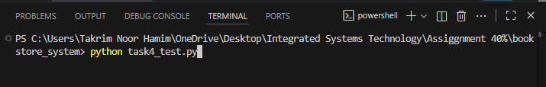

After Running it will demonstrate the API Simulation and Secure Coding:

Part A:

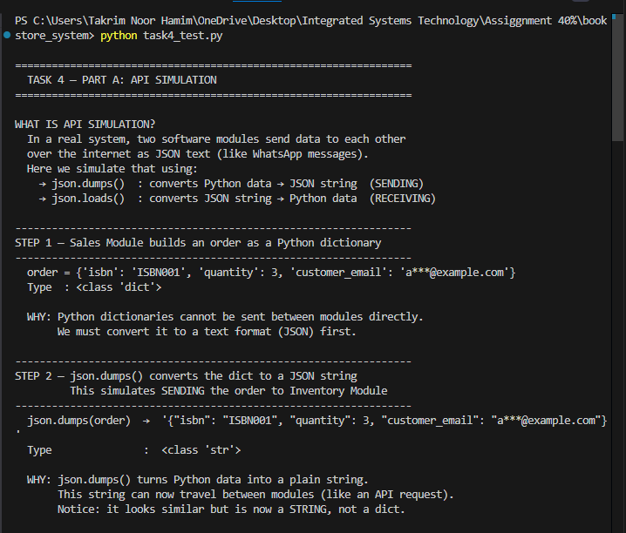
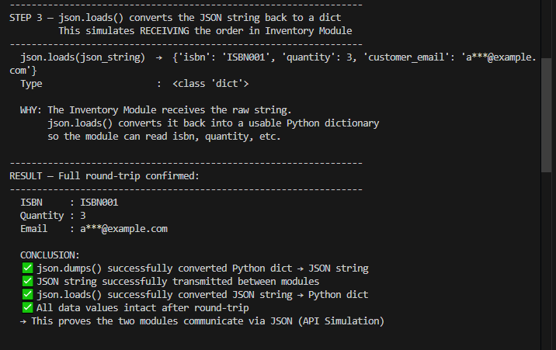

Part B:

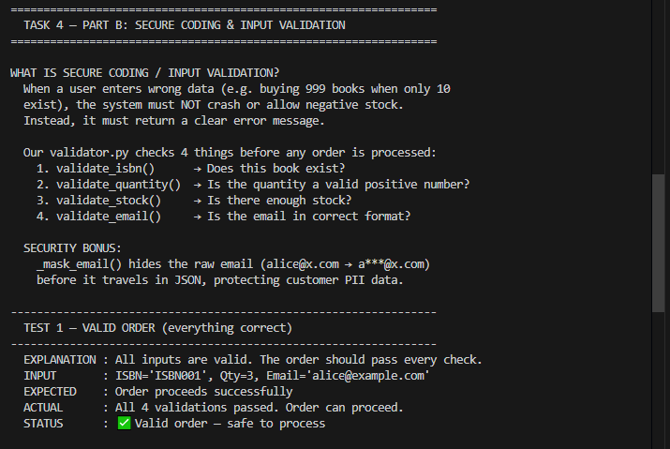
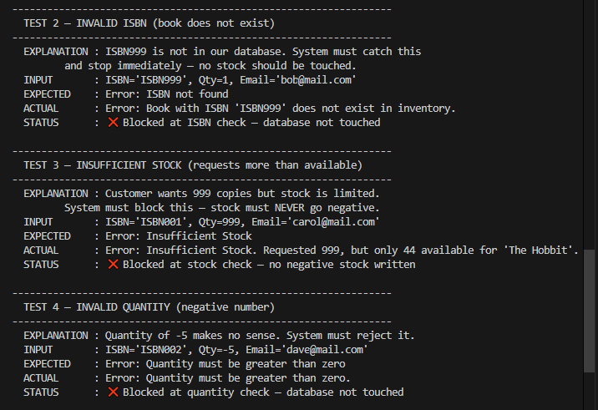
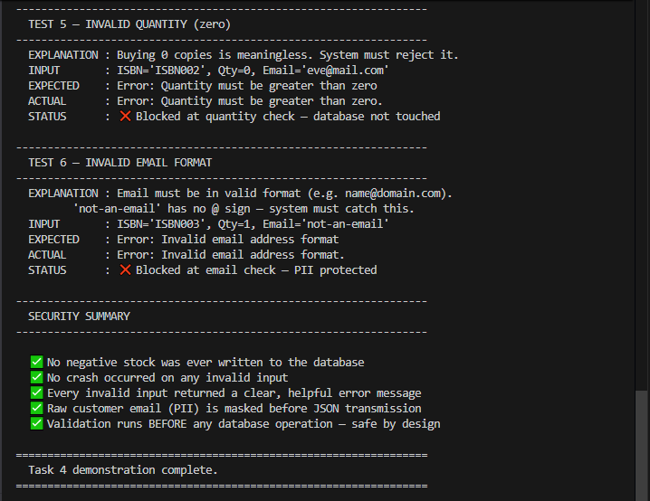

As you can see the result is saying it all, no need to describe more.

The current implementation uses a read-modify-write pattern for inventory updates, which is sufficient for a single-user system. In a multi-user production environment, a file lock (e.g. Python's fcntl) or a proper database (e.g. SQLite with transactions) would be required to prevent race conditions.

References

- Python Software Foundation (2024). json — JSON encoder and decoder. [online] Available at: https://docs.python.org/3/library/json.html [Accessed 7 March 2026].
- Python Software Foundation (2024). re — Regular expression operations. [online] Available at: https://docs.python.org/3/library/re.html [Accessed 7 March 2026].
- Martin, R.C. (2008). Clean Code: A Handbook of Agile Software Craftsmanship. Upper Saddle River, NJ: Prentice Hall.
- OWASP Foundation (2023). Input Validation Cheat Sheet. [online] Available at: https://cheatsheetseries.owasp.org/cheatsheets/Input_Validation_Cheat_Sheet.html [Accessed 7 March 2026].
- OWASP Foundation (2023). Personally Identifiable Information (PII) and Data Masking. [online] Available at: https://owasp.org/www-project-web-security-testing-guide/ [Accessed 7 March 2026].
- Matthes, E. (2019). Python Crash Course: A Hands-On, Project-Based Introduction to Programming. 2nd ed. San Francisco: No Starch Press.
- Ecma International (2017). The JSON Data Interchange Standard (ECMA-404). 2nd ed. [online] Available at: https://www.json.org/json-en.html [Accessed 7 March 2026].
- Lutz, M. (2013). Learning Python. 5th ed. Sebastopol, CA: O'Reilly Media.

